X – Approximate position – Crampton Pym & Lewis Solicitors

We have pedestrian access from Willow Street and vehicular access (including
disabled access) from Welsh Walls. Clients with an appointment are welcome
to use our car park.

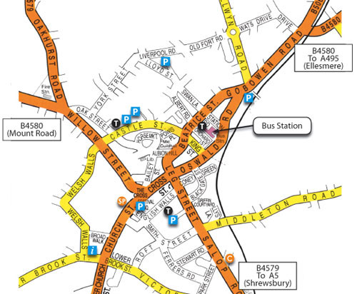

x

